Gunnedah South Public School

24/03/2020

Parents Remote Learning Guide K-6

We have put together this guide to assist parents and carers in setting up remote learning for students. It is important that parents and carers note the following:
- For the remainder of Term 1, student work sent home will consist of paper guides, booklets and resources.
- We are currently working towards establishing online platforms and lines of communication for teachers to assist with learning at home if needed given the current circumstances – we plan to move to this model Term 2

Being confined at home for extended period of time will add extra pressure to families and this can result in added stress. We suggest that parents set up a daily structure or routine to help keep their children occupied, entertained and keep some level of normality in their daily lives. Students should set themselves up with a work space that is clear from distractions (e.g. tvs, electronic devices) and gets them focused on learning.

The Premier has also said there will be one single unit of teaching for children at school and at home and the NSW Education Minister, Sarah Mitchell, said schools will move to an online learning model. Our learning continuity plan consists of three phases:

· Phase 1 – short term (Remainder of Term 1)

· Phase 2 – mid term (First weeks of Term 2)

· Phase 3 – long term (ongoing)

Communicating with your Child
We ask that you take time during your day to:
- talk to your whole family about what is happening. Understanding the situation will reduce their anxiety
- help your children to think about how they have coped with difficult situations in the past and reassure them that they will cope with this situation too. Remind them that the isolation won't last for long
- exercise regularly. Options could include exercise DVDs, dancing, floor exercises, yoga, walking around the backyard or using home exercise equipment, such as a stationary bicycle, if you have it. Exercise is a proven treatment for stress and depression
- encourage your children to keep in touch with family members and friends via telephone, email or social media (where appropriate)
- we hope to have set up Term 2 lines of online communication where students can get in touch with their peers and teachers. In the meantime, we strongly urge parents and carers to monitor ways in which children communicate with each other, avoiding platforms such as Facebook, Snapchat, etc. It has been well documented by our staff that these channels of communication lead to trouble. If a Telstra customer apply for the extra data.

Starting your Day
We encourage parents to start every day by giving students an overview of the planned activities. Discuss what tasks you will be setting for them throughout the day, when they will have breaks, what they will have for lunch and when they will get a chance to play. Perhaps parents could display this information on a whiteboard and wipe tasks off as they have been completed. This will help focus students and keep them relaxed.

Daily Timetable
We have included a timetable that we suggest parents and carers follow. The activities and times are just a guide. We expect parents and carers will need to make adjustments to suit their own daily routines and time constraints.
To assist parents and carers with multiple children, we have included activities for Kindergarten to Year 6 on the one timetable. This way students can be working on the same task but will have variations to suit their grade and/or ability. We ask that parents use their own judgement in allocating tasks – students should be given activities where they will have success. We have tried to allocate work that students can complete independently. Please make further adjustments to tasks to suit students’ interests and ability. For instance, if your child struggles with reading, parents could read to them instead.

Booklets
To assist parents and carers with remote learning, we have compiled some booklets of worksheets for the students to complete. We have worked with teachers to send home work that students can complete independently and not find too difficult. For this reason, booklets have been given to students based on their learning needs.
Parents will also find that we have included some answer pages. We recommend that once work is completed, that students and parents together use these answer pages to check their work and fix any mistakes.

Accessing Digital Learning Platforms
In addition to our suggested daily timetable, we have purchased a 12 month school subscription to Reading Eggs, Eggs Express and Mathletics. Log in details have been included in these packs. We recommend that parents and carers follow our suggested timetable, and ask students to complete some ‘hands on’ tasks first and use these fun apps as a reward. Please ensure initially students complete the reading eggs assessment as this will place your child automatically on the appropriate level. Mathletics is pre-set to your child’s grade level, class teachers will adjust levels accordingly. Please be mindful that kids actually will need to complete set items in Mathletics as well (cool maths games is not the teaching – it is the fun follow up).

Additional Tasks and Activities
If parents and carers would like to set up their own lists of learning tasks for children, please feel free to do so. Learning can occur during all sorts of activities and this time may present parents and carers with an opportunity to address things that time has not permitted before.

You will find below a grid of general learning activities that suit students in Years K-2 and Year 3-6. We have selected a range of activities and tasks that allow students to learn and practice important skills important to their stage of development. For instance, students in Years K-2 need to maintain strong fine motor skills – so we have recommended lots of activities where they can keep up the strength in their hands.

Years K-2 Suggested Grid
Learn how to tie shoelaces | Build something out of Lego | Teach your children how to make their bed
Show your children how to turn their clothes through, fold and place in their draws | Cook something together | Write a letter to a grandparent
Talk about how to brush teeth correctly | Complete a weaving activity | Learn a new card game
Make a joke book | Make or do a jigsaw puzzle | Build the tallest tower from materials you have at home
Cut some strips out of paper and make a paper chain | Work together in the garden | Make some sculptures from playdough
Write out your full name neatly | Practice saying and/or writing your address and phone number | Make a sculpture or artwork out of recycled materials or craft supplies you have at home
Ask each member of your family what their favourite colour is. Show their answers in a picture graph. | Time yourself to write out your spelling words | Play a board game
Paint your finger nails | Sort a variety of shapes and objects | Learn your birth date

Year 3-6 Suggested Grid - Reading
Rule 3 columns for nouns, verbs and adjectives from a book you’ve read | Watch a movie and write a review | Favourite Part  What was your favourite  part of the text? Why?  Detail your reasons in  full sentences.
Character Map  Draw a picture of a  character in your text.  Label your character. | Visualisation  Read a page or two of a  story and draw a picture  of what is happening  from what you visualised  in your head. | Summarising  Jot down as many V.I.P’s  (Very Important Points)  from the text as you can
Questioning  Before reading an  information text, write ‘I  wonder’ in the middle of  the page. Next, write  questions you have  about the topic before  reading. Once you read  the text, write down the  answers to your  questions. | Text-to-world  Connection  List down how this text  relates to something  that has happened in  the real world | Character Map  Draw a picture of a  character in your text.  Label your character.
Inferring  What’s in my teacher’s  bag or trash?  Make inferences about  what is in their bag  based on what you know  about your teacher. | Activating Prior  Knowledge  Choose a topic and write  what you already know,  then research the topic  and in a second column,  write what you now  know. | Scanning  Scan a newspaper and  find the following: birth  notice, weather  forecast, advertisement,  sports result, good news  article and bad news  article.  Glue them under their  headings if you wish.
B-M-E  Identify and summarise  in paragraphs the  Beginning, middle and  end of your story. | Different Ending  Change the ending of  your story. Illustrate  after you have written. | Tricky Words  Write down any tricky  words you come across  while reading. Find them  in a dictionary and write  the meaning down.
Non Fiction  List 3 interesting facts  you read in your book.  Complete some extra  research and add some  more facts | Retell  After reading the story,  retell it to a family  member using first, next,  lastly. | Setting  What is the setting of  your story? Write about  it in detail.

Year 3-6 Suggested Grid – Spelling
Students and parents will find we have included spelling lists for each grade in this guide. Each day students could choose one activity from the grid below and practice their spelling words. We will soon have an online platform set up where students will be able to post pictures of their work for their teachers to see (we hope to have this up and running Term 2).
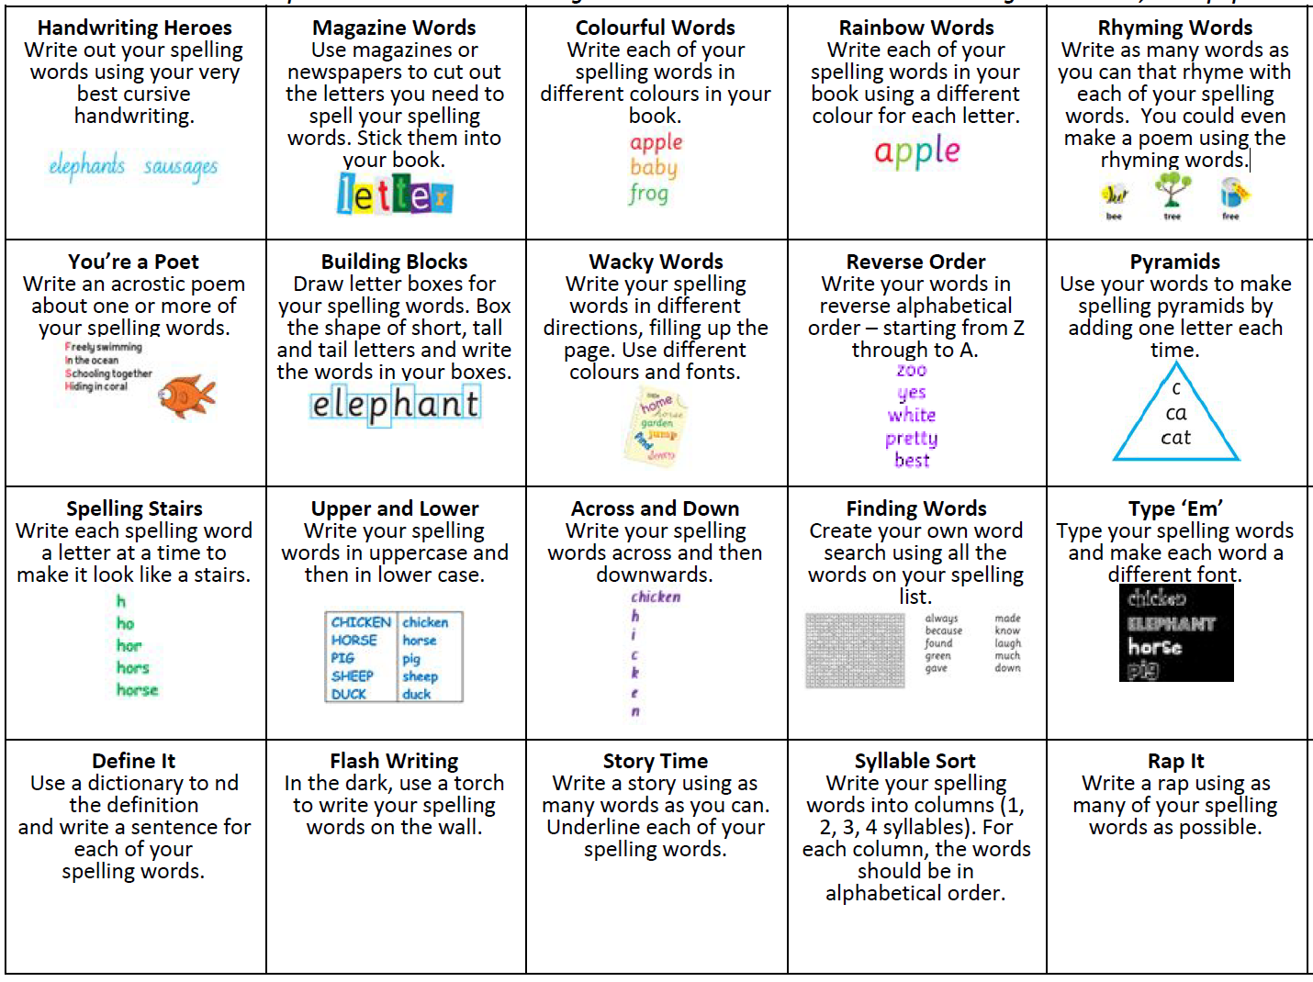
Year 3-6 Suggested Grid – Creative Arts
Dance  Choose your favourite  song and choreography  some dance moves | Drama  Turn a section of your  favourite book or novel  into a script for readers  theatre. Perhaps  perform your script with  your siblings and record | Drama  Play a mime game with  your family. Each  member acts out an  everyday activity or  chore and others try to  guess the activity
Dance  Play a game of freeze  with your family. Apply a  certain style of dancing  for each song | Visual Arts  Use a camera or  smartphone to create  different viewpoints of  the same object. Try and  sketch these. | Visual Arts  Gather 3-5 objects from  around your house and  arrange them to draw a  still life
Music  Follow and learn a ‘cup  percussion’ video.  Record your attempt | Drama  Write a short play or skit  and perform to your  family | Music  STOMP is famous for  playing percussion music  using everyday objects.  Try to make a piece of  music using everyday  objects around the  home.

Year 3-6 Suggested Grid – Other Subjects
Technology has changed a lot over time. Talk to your parents/grandparents about what the technology was like when they were children. Identify similarities and differences between the old and the new technology | Set up two plastic cups with  the same number of ice  cubes and place them in  different places to see what  happens. Tell a family  member your prediction  (what you think will happen) | Ask each member of your  family what their favourite  colour is. Show their  answers in a picture graph
Watch a documentary and take notes | Observe the weather for the week by drawing or writing about the weather each day. Make your own weather chart for the week | Journal writing – write and draw how you’re feeling today.
Make a paper airplane. Measure how many steps the plane flies. Try a new design to see if you can beat that distance. | Work together in the garden | Design a healthy menu for a  day at home.  Present the menu to your  family in a creative way.

Online Learning Platforms
For the remainder of Term 1 all copies of information, resources and booklets will be available to parents via our school website. We are currently setting up online platforms for communication through Microsoft Teams. This will be rolled out to students Term 2. Students at school will be doing exactly the same work.

In the meantime, we need you to help ensure that students each know their email addresses. We have included a copy of your child’s email address in this pack.

Updating Parents
We will continue to update parents with any latest information using our school Facebook page and the SkoolBag App.

Educational Websites
Below is a list of educational websites parents and carers may wish to use to supplement student learning.

https://theschoolmagazine.com.au/explore - A collection of plays, poems, stories and comics. This is not the full catalogue, but samples are available.

https://www.literacyshed.com/home.html - Literacy Shed External link for students K-6. Range of free reading materials.

http://www.pobble365.com/ - Pobble365 External link for K-6. Online daily visual with writing, grammar and speaking and listening activities.

https://www.storylineonline.net/ - Storyline Online External link for K-6. Videos featuring celebrated actors reading children’s books alongside illustrations.

https://www.kidsnews.com.au/news - Kids News External link for 2-8. Newspaper articles for teachers using current daily news. The content is written into educational stories in child appropriate language and filtered/censored to remove any inappropriate content or imagery.

http://www.readwritethink.org/classroom-resources/student-interactives/#top-tabs - Read Write ThinkExternal link for K-12. Range of online activities that can be refined into grade, learning objectives and focus.

https://www.spellingcity.com/ - Vocabulary Spelling City External link for K-6. A free version is available. A range of spelling games and quizzes are accessible.

https://thekidshouldseethis.com/ - Free collection of over 4,300 kid-friendly videos, curated for teachers and parents to share meaningful media in the classroom. Useful as a writing prompt for informative, persuasive and imaginative texts.

https://www.sea.museum/discover/apps-and-games/voyage-game - Voyage Game External link Australian National Maritime Museum – Games-based learning resource exploring convict transport in 1830 from England to Australia.

https://mrsbmusicroom.com/ - Mrs B’s Music Room External link technology and music

https://www.teachstarter.com/au/blog/drama-games-lesson-ideas-activities-for-kids-k-3/ - Drama Activities for K-3 student’s External link

If you have any Questions??
If parents and carers have any questions regarding remote learning they can contact Stage APs by calling the school office on (02) 67421899.

Spelling Lists
Year 1 Year 2
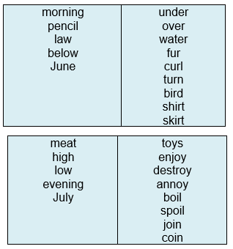
next  come  all  today  Friday | black  block  blue  blow  blink
good  not  just  Saturday  Sunday | eggs  Easter  bunny  hunt  chocolate

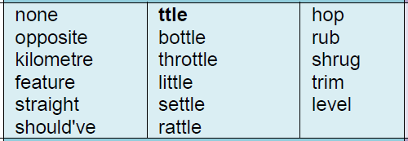
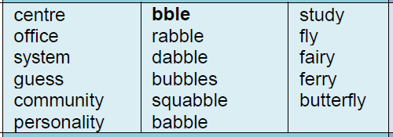
Year 3 Year 4
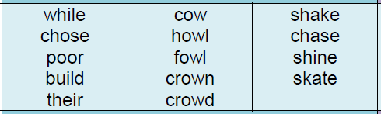
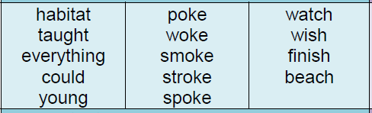
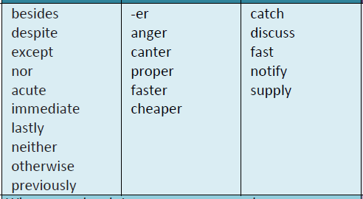
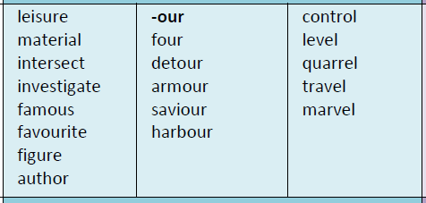
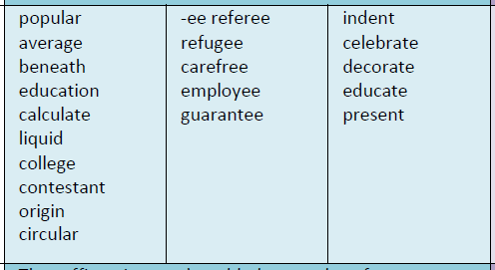
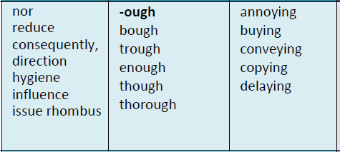
Year 5 Year 6

Suggested Timetable - Weekly Overview
Monday | Tuesday | Wednesday | Thursday | Friday
Writing  Option 1: Write about what did you do on the weekend? Try and include who, when, where, why, what.  Option 2: Write a narrative using this starter:  “What on earth are you doing up there?” mum exclaimed. | Writing  Option 1: Write about what can you see out your window or door? Use adjectives (describing words) when you write what you can see.  Option 2: Continue writing your story or edit and correct any mistakes. | Writing  Option 1: Write a narrative using this starter:  Wow, it was so hairy. I cannot believe it was in my home…  Option 2: Ask your parent or carer for some feedback on your writing. What changes could you make? | Writing  Option 1: Write a letter to a friend using some of your spelling words.  Option 2: Continue to work on your story. Write out a second draft. | Writing  Option 1: Write a list of food you would like for a dinner. Think of a main dish and dessert.  Option 2: Publish your story by writing a final copy on paper or typing it onto a Word Document.
Booklet Time  Choose at least 2 pages on either reading, writing or spelling to complete from your booklet | Booklet Time  Choose at least 2 pages on either reading, writing or spelling to complete from your booklet | Booklet Time  Choose at least 2 pages on either reading, writing or spelling to complete from your booklet | Booklet Time  Choose at least 2 pages on either reading, writing or spelling to complete from your booklet | Booklet Time  Choose at least 2 pages on either reading, writing or spelling to complete from your booklet
Morning Tea Break | Morning Tea Break | Morning Tea Break | Morning Tea Break | Morning Tea Break
Reading  Choose a book to read aloud with a parent/carer. Before reading, look at the front cover and ask ‘what do you think is going to happen in this story?’  Read the book aloud together. Answer these questions.  - What was this book about?  - What happened at the beginning, middle and end? | Reading  Choose a book to read aloud with a parent/carer. Before reading the book, talk about what you think is going to happen by looking at the pictures?  - What do you think will happen at the end of the story?  - What do you think is going to happen next in the story based on what you already know? | Reading  Choose a book to read aloud with a parent/carer.  Read the book aloud together. Answer these questions.  - What was this book about?  - What are three facts you have learnt from reading it? | Reading  Choose a book to read aloud with a parent/carer.  - Read it aloud together.  - Does it have a good beginning and ending?  - Are the characters interesting? What makes them interesting?  - Which illustration in the story was your favourite? Why? | Reading  Choose a book to read aloud with a parent/carer. Read it aloud together.  - How does the title describe the content of the book?  - Was the title a good one for this book? Why or why not?
Reading Eggs  Complete one lesson on the Reading Eggs Program. | Reading Eggs  Complete one lesson on the Reading Eggs Program. | Reading Eggs  Complete one lesson on the Reading Eggs Program. | Reading Eggs  Complete one lesson on the Reading Eggs Program. | Reading Eggs  Complete one lesson on the Reading Eggs Program.

Monday | Tuesday | Wednesday | Thursday | Friday
Lunchtime Break | Lunchtime Break | Lunchtime Break | Lunchtime Break | Lunchtime Break
Booklet Time  Choose at least 2 maths pages to complete from your booklet | Booklet Time  Choose at least 2 maths pages to complete from your booklet | Booklet Time  Choose at least 2 maths pages to complete from your booklet | Booklet Time  Choose at least 2 maths pages to complete from your booklet | Booklet Time  Choose at least 2 maths pages to complete from your booklet
Additional Task off the Grid  Choose an activity off the Additional Activity or Task Grid | Additional Task off the Grid  Choose an activity off the Additional Activity or Task Grid | Additional Task off the Grid  Choose an activity off the Additional Activity or Task Grid | Additional Task off the Grid  Choose an activity off the Additional Activity or Task Grid | Additional Task off the Grid  Choose an activity off the Additional Activity or Task Grid

